Northway Community Primary School

Northway EYFS Handbook

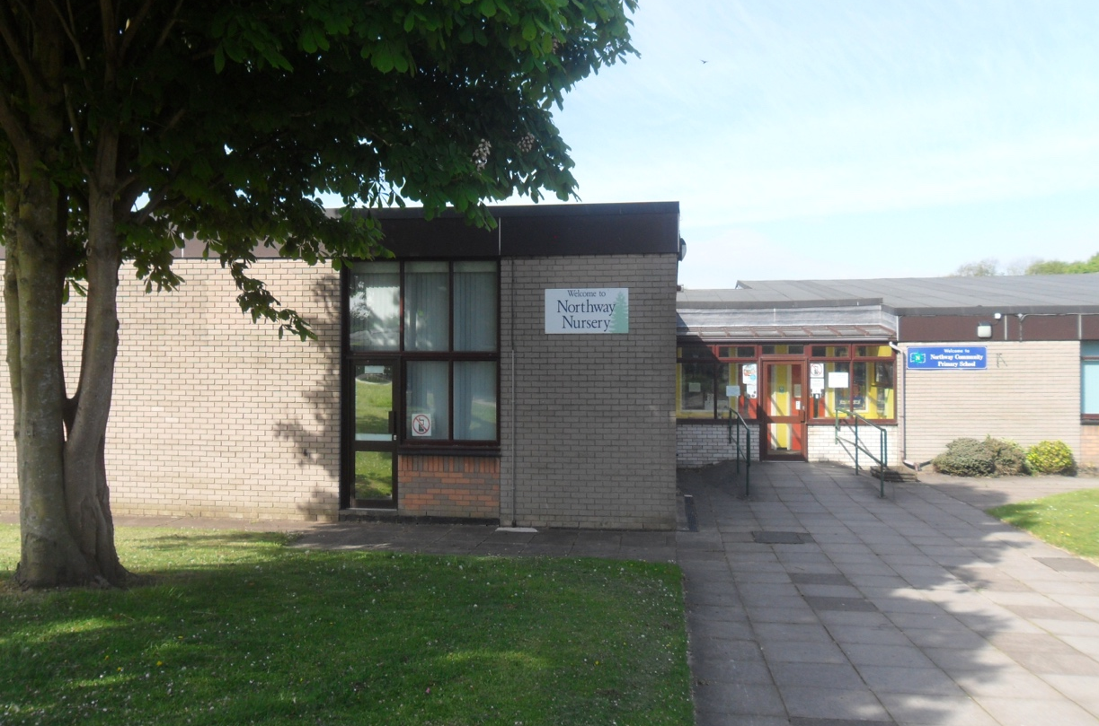
www.northwayprimary.co.uk

Our Vision at Northway.

Welcome to Northway EYFS. This handbook is a guide to all staff to ensure that a consistent approach and ethos is developed from the moment a child enters our setting.

Nurturing today’s minds for tomorrow’s challenges.

We start by considering our school motto. How can we nurture and prepare a child adequately for tomorrow’s challenges if we do not foster a love of learning, build self-confidence and self-belief and develop resilience?
It is an impossible task. Here at Northway, we begin the learning journey by showing the children how to tackle challenges independently, with a resilient spirit and with the confidence that mistakes and challenges are a natural occurrence on our path to achievement.
We pride ourselves on creating a progressive curriculum that is exciting, challenging and stretches each individual child to their full potential.

At Northway, we believe that the first years in education are a vital time for preparing children for their future learning journey. Children learn best when they are happy, secure and have a high sense of wellbeing. Staff place a strong emphasis on providing our children with a safe and friendly environment to develop in. Through play experiences and purposeful teaching, our children become confident to explore and enthusiastic to learn. Across the year, we explore our school values and a strong focus is placed on nurturing children to become resilient, confident and independent learners. This is achieved by the ethos we create using metacognition and teacher scaffolding. Personal, social and emotional development, alongside the teaching of communication and language skills, underpin the foundations for learning at Northway. We consider social skills and positive interactions with adults and peers crucial for children to be able to learn and thrive as they develop.

We build on children’s prior learning from previous settings and from home to ensure that learning is meaningful, relevant and tailored to individual needs, interests and learning styles. We strive to promote the holistic development of all children in order to build a solid and broad foundation for lifelong learning. Through progressive planning and teaching, we ensure that all our pupils are ‘school ready’ academically, personally, socially and emotionally.

High expectations and aspirations are set for all children to achieve their full potential and to become competent in the basic skills of reading, writing and number, so that many possibilities are made available to them as they progress through the school.
How do we achieve our aims?
1) We place a strong value on the power of teaching and through careful planning we ensure high quality teaching takes place across the setting.
The EEF’s (Education Endowment Foundation) best available evidence indicates that great teaching is the most important lever schools have to improve pupil attainment. Ensuring every teacher and member of staff is supported in delivering high-quality teaching is essential to achieving the best outcomes for all pupils, particularly the most disadvantaged pupils.
At Northway we consider how children learn, how they develop knowledge and skills, and how they can be supported to lay firm foundations for later learning. Teaching approaches that ensure long-term retention of knowledge, fluency in key skills, developing a growth mindset and confident use of metacognitive strategies are crucial. These are fundamental to learning and are the ‘bread and butter’ of our teaching:
- Cognitive strategies include subject-specific strategies or memorisation techniques such as methods to solve problems in maths.
- Metacognitive strategies are what we use to monitor or control our cognition, for example checking whether our approach to solving a mathematics problem worked or considering which cognitive strategy is the best fit for a task.
We are mindful of the differing needs within our classes, it is just as important to avoid over-scaffolding as it is to ensure all pupils are adequately supported. Similarly, we know that retrieval practice supports knowledge retention, but it is important to think carefully about how this is implemented in individual subjects across the curriculum to ensure it supports learning.
What does this look like in practice?
- Teachers will not leave learning to chance, whilst incidental learning is imperative, progressive and sequential planning is vital to build secure foundations of learning.
- Planning is designed in conjunction with the previous and future year groups to ensure schemas are developed over time and prior knowledge is retrieved regularly.
- Teachers and support staff will spend an equal proportion of their day teaching carefully planned concepts, knowledge and skills to the whole class, small groups and on a 1:1 level.
- Teachers and support staff will work with children in small groups or one to one following a teaching input to secure, consolidate or stretch a child’s understanding further.
- The language that we use will support the development of growth mind set and metacognitive strategies.

2) We place a strong value on independent, self-regulated learning.
Research shows that the explicit teaching of cognitive and metacognitive strategies is integral to high-quality teaching and learning, and these strategies are best taught within a subject and phase-specific context. Approaches such as explicit instruction, scaffolding and flexible grouping are all key components of high-quality teaching and learning for pupils.
Self-regulated learners are aware of their strengths and weaknesses, and can motivate themselves to engage in, and improve, their learning. At the heart of this is metacognition. Beyond it’s simple definition of ‘thinking about thinking’, staff at Northway continually develop their understanding of what this means, looks like in practice and how it can be used to improve pupils’ metacognition.
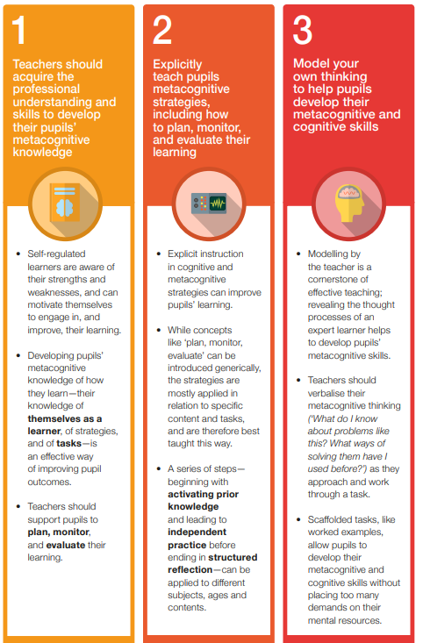

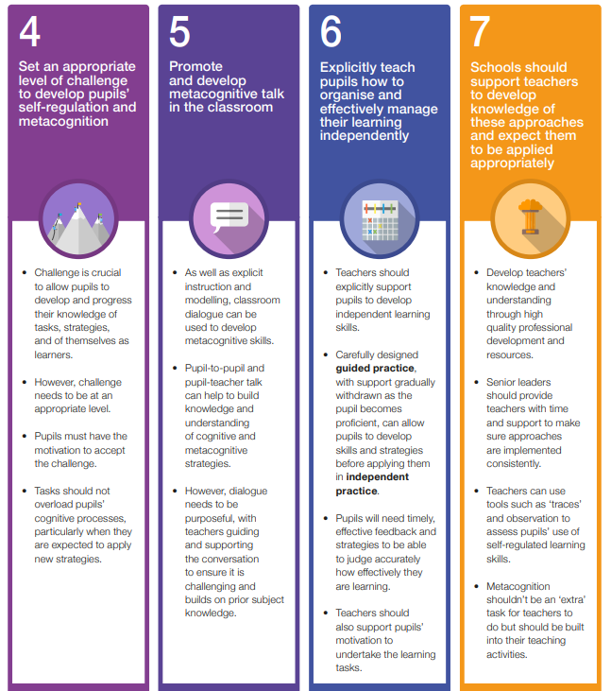
At Northway we model our own thinking to help pupils develop their metacognitive and cognitive skills.
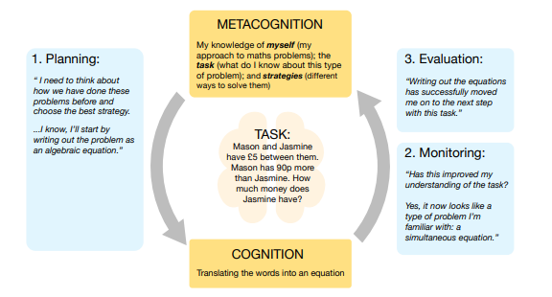
“The most effective teachers—like a master craftsman working with his novice apprentice— are aware of their expertise and of how to reveal their skills to learners. All teachers use modelling to some extent. The most effective teachers, are aware of their expertise and of how to reveal their skills to learners and how to assess whether their pupils have understood them; they are metacognitive about their teaching.”
EEF EYFS

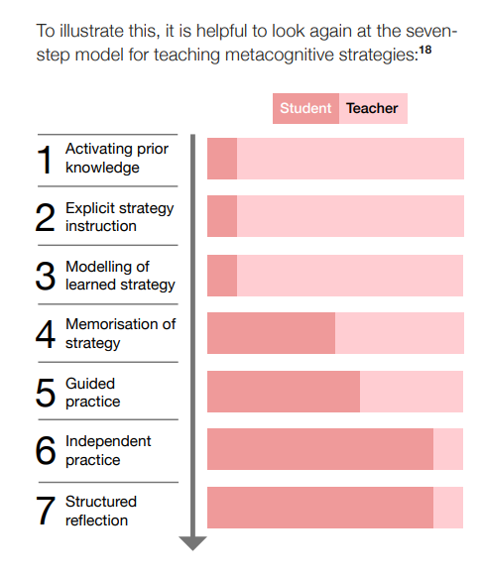
Models taken from EYFS EEF
At Northway we follow the model above, gradually moving from teacher led/guided activities to pupils becoming equipped to independently learn and consolidate skills.

What does this look like in practice?
- We will praise the effort, not simply the outcome, of a child’s learning so that they understand the value of our attitude towards learning and our ability to learn through trial and error is key for development.
- If children do not grasp a concept, we will re-word and re-model the concept in a different way.
- If children do not grasp a concept, we will explore through questioning their current understanding so that we can identify the misconception or barrier to learning.
- If children do not grasp a concept, we will point them to visual resources that will help them to retrieve prior knowledge to support their current learning.
- We will carefully plan for and model our own thinking to help pupils develop their metacognitive and cognitive skills.
- We will break learning down to its simplest form until a child is secure and ready to move on.
- Teachers and support staff will give children time to think, ponder and explore.
- Children are not placed into ’NAMED’ groups or assigned a table to complete tasks at. Whilst in the EYFS, their groupings are fluid and flexible to avoid early self-concepts.

3) We place a strong value on the development of PSED skills.
Teachers and staff are skilled at imparting skills and knowledge and ways to remember that. It is vital that children learn to recognise their strengths and weaknesses and how to overcome barriers with resilience and an ‘I can’ attitude. In the EYFS, a high proportion of time is spent on developing CLL as we believe that this is the key to supporting all other learning and the vehicle through which children can express themselves.

Communication and language PSED

Metacognition EYFS EEF
The triangulation of teaching high quality CLL, PSED and Metacognition is what we believe supports the whole development of a child.
What does this look like in practice?
- Learning to learn skills, growth mind-set and self-regulation skills are engrained in staff’s language and teaching.
- PSED is built into almost all of the taught sessions in Nursery and Reception.
- PSED is discretely taught for an afternoon a week in Reception.
- Children take part in the whole school events from the SMSC calendar.
- From Reception, we include all children in whole school assemblies where our school ethos is consolidated.
- Teachers use metacognitive skills to model how to express and articulate ideas and experiences in PSED lessons.
- At an age-appropriate level, we lay the foundations for educating young children about protected characteristics. We follow the theme below, which fits into a larger picture throughout the school.
EYFS: Breaking down early stereotypes
- The introduction of the concept that certain activities/games/preferences are not confined to a particular gender.
- The removal of the concept that certain colours are linked with gender.
- The introduction of the concept that friendships are not confined to gender/race/ability/religion.
- The introduction of the concept that age should not place limitations on a child's right to be happy, healthy and safe.
- We give frequent and clear signposts for children to be able to talk to an adult if they feel unhappy or unsafe.

4) We place a strong value on the development of communication and language skills.
Evidence collated by the EYFS EEF states that Communication and Language approaches emphasise the importance of spoken language and verbal interaction for young children. They are based on the idea that children’s language development benefits from approaches that explicitly support communication through talking, verbal expression, modelling language and reasoning. Effective communication and language approaches used in the early years include reading aloud to children and discussing books, explicitly extending children’s spoken vocabulary by introducing them to new words in context, and drawing attention to letters and sounds. They also include approaches more directly aimed at developing thinking and understanding through language, such as ‘sustained shared thinking‘ or ‘guided interaction’. Overall, studies of communication and language approaches consistently show positive benefits for young children’s learning, including their spoken language skills, their expressive vocabulary and their early reading skills. Studies show that on average, children who are involved in communication and language approaches make approximately six months’ additional progress over the course of a year. There is consistent evidence that reading to young children, and encouraging them to answer questions and talk about the story with a trained adult, is a highly effective approach.
The ‘Bold Beginnings’ (OFSTED) research stated that in highly effective schools:
‘Reading was at the heart of the curriculum in the most successful classes. Listening to stories, poems and rhymes fed children’s imagination, enhanced their vocabulary and developed their comprehension. Systematic synthetic phonics played a critical role in teaching children the alphabetic code and, since this knowledge is also essential for spelling, good phonics teaching supported children’s early writing.’

At Northway, a large proportion of our daily activities centre around developing CLL skills as we have seen the impact that this has on a child’s holistic development, well-being and academic success.
What does this look like in practice?
- When planning, teachers consider metacognitive learning and a progressive curriculum that explores books and vocabulary. (See MTPS)
- The teaching of new vocabulary is explicit and a high emphasis is placed on exploring and modelling language during play.
- Daily CLL lessons are taught following a carefully mapped out progression map. Lessons are detailed and link to stimulating texts and themes that interest our children.
- Answering questions about a story is built into the curriculum and carefully planned for.
- Daily story and rhyme time is planned into the timetable and a high proportion of time is given to exploring and discussing books.
- Daily phonics and reading time is planned into the timetable in addition to the CLL lesson.
- Speech and language groups are formed to support language and communication development. Children are supported to articulate and express their ideas and experiences verbally.
- Nursery and Reception work closely to share good practice and continue speech and language support throughout the EYFS and beyond.
- A large proportion of the daily timetable is given to developing CLL, reading and phonic skills.
- EYFS teachers have been trained in ‘Sustained shared thinking’ techniques and model this to all staff that work in EYFS.
- Each Reception child has an Active Learn account and Phonics Play login, these are online learning platforms to support literacy skills that children can explore at home.
5) We place a strong value on the development of mathematical skills.
The EYFS EEF research shows that on average, early numeracy approaches have a positive impact on learning equivalent to approximately six additional months’ progress for early mathematics outcomes. There is some variation between approaches, which suggests that the choice of approach and the way in which strategies are introduced are important. Approaches tend to produce larger effects when they are designed to develop a particular mathematical skill (such a counting or estimating), commit a regular amount of time to developing mathematics (between two and three hours per week), designed specifically for the early years setting involved, and include some specific individual interaction.
Commonly, the most effective early numeracy approaches include individual and small group work, and balance guided interaction with both direct teaching and child-led activities, depending on the age and capabilities of the child.
The ‘Bold Beginnings’ (OFSTED) research stated that in highly effective schools:
‘The schools that ensured good progression frequently used practical equipment to support children’s grasp of numbers and, importantly, to develop their understanding of linking concrete experience with visual and symbolic representations. More formal, written recording was introduced, but only when understanding at each stage was secure and automatic.’
At Northway we believe that giving a child a strong understanding of the basic skills, reading writing and mathematics is vital for the future development of every child. When we teach maths in EYFS, we view it as a very important tool for developing language, problem solving and investigation skills.
What does this look like in practice?
- We have a progressive curriculum planned out to tackle early mathematical concepts.
(See LTP and MTP’s for detailed progression maps)
- We have a daily focus on mathematics, making sure that all children have accessed mathematical teaching at their level.
- A range of approaches to develop number skills are used to improve young children’s knowledge and understanding of early mathematical concepts.
- Whole class, small group and individual work take place depending on the needs of the children.
- A balance between guided interaction and child-led activities is planned for according to the capabilities of the child.
- We use a wide range of equipment, visual and symbolic representations to support mathematical development before we introduce more formal written methods.
- Intervention groups are used throughout the year to plug gaps in learning and consolidate key mathematical skills.
- Each Reception child has a Doodle math’s account, which is an online learning platform for children to explore at home.

Bold Beginnings at Northway

In the ‘Bold Beginnings’ research published by OFSTED it is stated that,

‘A good early education is the foundation for later success. For too many children, however, their Reception Year is a missed opportunity that can leave them exposed to all the painful and unnecessary consequences of falling behind their peers.’

‘Successful schools made sure that they gave reading, writing and mathematics in their Reception classes, sufficient direct teaching time every day, with frequent opportunities for children to practise and consolidate their growing knowledge. The headteachers made sure that their curriculum was fit for purpose, so that children were equipped to meet the challenges of Year 1 and beyond.’

At Northway we want to make sure that all children of all backgrounds and abilities are taught a challenging and aspirational curriculum from the moment they enter our setting. We are proud to say that our curriculum ensures that all children make excellent progress from their starting points. Our teaching is well thought out, progressive and balances play with direct teaching to ensure all children meet their full potential.

We understand that teaching has a range of different purposes and we value the power of play for developing children’s personal, social and emotional skills as well as consolidating all that they have been taught about communication and language.

